**Network Virtualization Concepts**

Self-Paced Microcourse

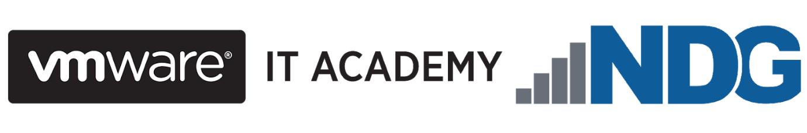



At the end of the course, you should be able to

* articulate NSX capabilities and benefits
* describe the major VMware NSX® components in the data, management, and control planes and their interactions
* apply relevant NSX features to use cases
* explain NSX network virtualization components and services
* explain how network virtualization is utilized in an SDDC environment

**Module 2: Introduction to Network Virtualization**

NDG - Network Development Group

**VMware** is a cloud computing and virtualization software provider for X86 or IBM compatible computers and servers. ... With **VMware** server virtualization, a hypervisor is installed on the physical server to allow for multiple virtual machines (VMs) to run on the same physical server.

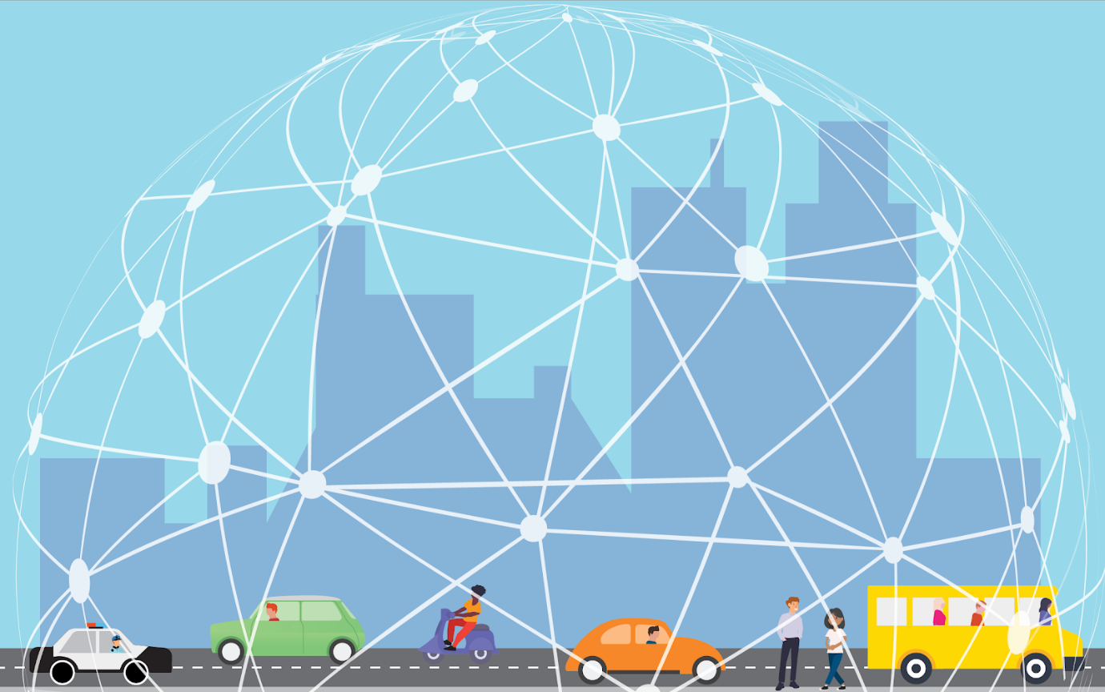

A 5G world has virtualization at its core. As the number of out connected devices mushrooms from the hundreds of millions to the tens of billions, data centers are relying more and more on virtualized infrastructure to handle the tsunami of data that we're producing and consuming. And it's not just data centers: the fact that 100% of the Fortune 100 companies use virtualization (and VMware virtualization technology at that), tells its own story.

In the Software-Defined Data Center (SDDC), compute, networking, and storage infrastructure is virtualized so that resources can be pooled and used more efficiently, less expensively, and faster. Real strides have been made in server (compute) virtualization and are increasingly being seen with storage virtualization.

The efficiencies gained from them, however, have been limited to a certain extent by legacy, (i.e, traditional, non-virtual) network infrastructure that's still reliant on physical hardware and mainly manual processes. While an organization's virtualized compute and storage may be dynamic, agile, and flexible, its legacy networking just can't keep up. And an infrastructure or organization that can't keep up often gets left behind.

Network virtualization enables the speed, mobility, and security, needed in a 5G world. Infrastructure can be made ready for new applications or be changed in minutes, rather than days or weeks. Apps and workloads are no longer restricted to individual physical subnets, neither are switches, routers, firewalls, etc. The security focus moves from simply protecting the perimeter (the *outside* surface) of a data center's infrastructure to providing the ability to give each virtual machine and virtual network its own firewall, shifting the focus to the *inside* perimeter of the data center and reducing the attack surface. In addition, virtual networks are isolated. and (as we will learn later in this course) segmented from each other and from the underlying physical infrastructure so that threats cannot be spread if they do get in.

Network virtualization extends these features and many others to the cloud as well, a critical factor to the 81% of enterprises that now use multiple cloud deployment models.

## What is Network Virtualization?

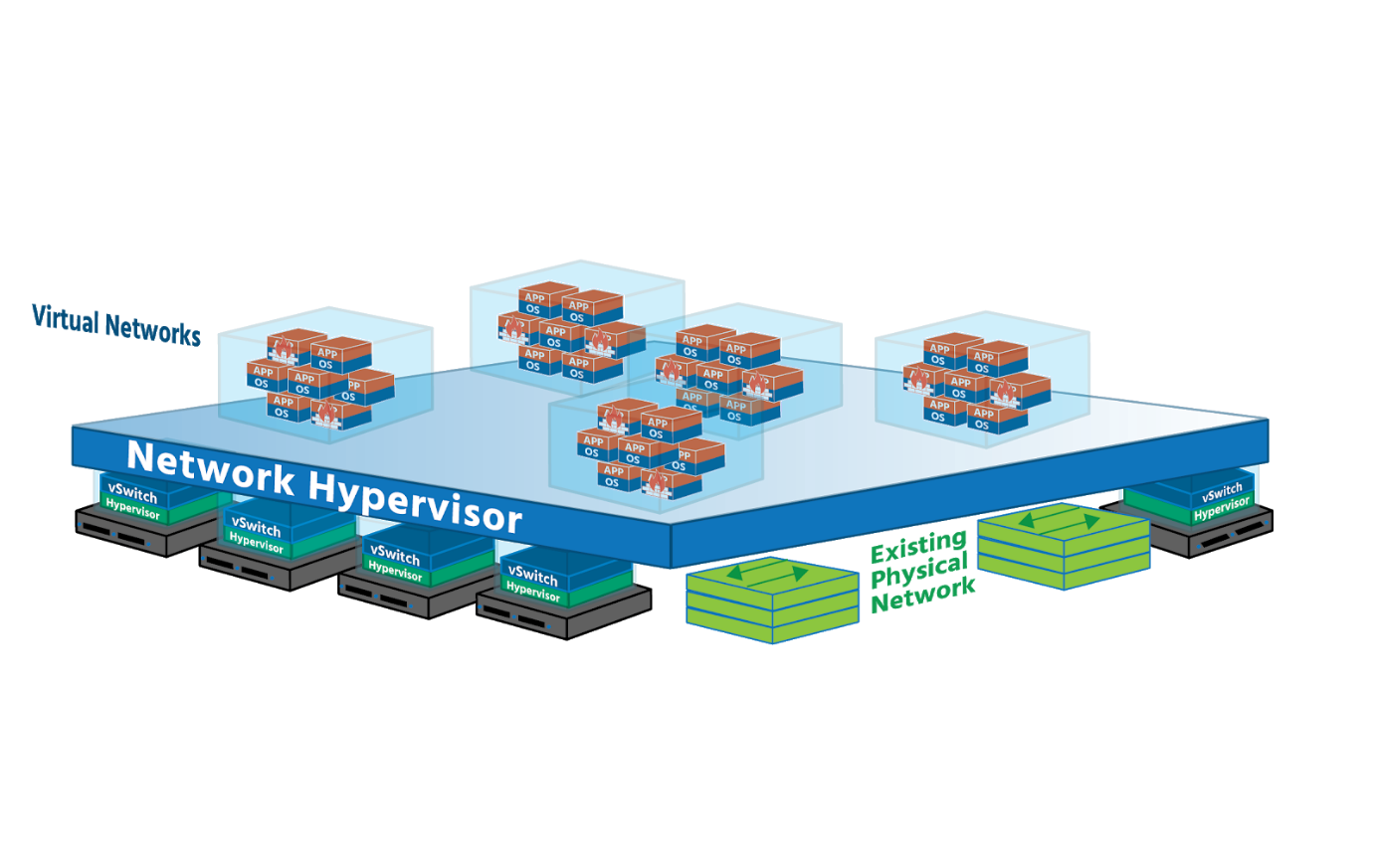

Network virtualization totally separates network resources from physical hardware by recreating those networking resources in software- by virtualizing them. Physical routers (which forwards data across multiple networks,) switches (which forwards data on a single *Local Area Network* or *LAN*) and load balancers (which even out workloads to prevent servers from being overwhelmed) are virtualized in the hypervisor layer using off-the-shelf, industry-standard servers (server/compute hosts). This virtualized pool can then be used as needed, on-demand. The underlying physical hardware remains important (it's still used for forwarding) but no longer needs to be reconfigured every time a new VM or container is added or updated, or every time a device on the network is moved to a different part of the network. The whole network can now be run in software.

This hypervisor-based networking software (which will include security services as well) uses a **controller** to send network services to virtual switches and *attaches* the services to individual *virtual machines (VMs)* and containers. The result is a virtual network (The exact services will be determined by the policies already assigned to the VM/containers.). In this virtual network, whenever new VMs and containers are created, the appropriate policies are automatically applied to them, and when VMs and containers move, their networking and security move with them. (You'll sometimes hear VMs and containers referred to as *workloads*, so we'll use that term here to familiarize you with it.)

Creating a virtual network on top of a physical network is known as **overlay networking**. Imagine two devices (or *endpoints*) on an organization’s network – *Finance Department Laptop* and *Sales Department Laptop*, for example, both connected to physical network ports. (VMs and containers can be *endpoints*, too.) Both laptops are given a virtual network ID (*VNID*) and assigned to a virtual network. Virtual switches then connect *Finance Department Laptop* to *Sales Department Laptop* via virtual links (software representations of physical links) that form a tunnel across the network. Each virtual link corresponds to a path in the underlying physical network.

Network virtualization works just as well in the cloud and can be managed by using a Cloud Management Platform (*CMP*) such as *VMware’s vRealize Automation* or an open-source option such as *Apache CloudStack* and *OpenStack*. Hypervisor-based network virtualization can be set up and run using a Graphical User Interface (*GUI*) and a Command-Line Interface (*CLI*) or using Application Programming Interfaces (*APIs*).

Network virtualization provides administrators with tremendous flexibility. It can be used for networks as small as two connected devices, or as large as networks spanning multiple sites of major enterprises. In addition, it is flexible enough to work with any cloud or cluster (or pod if you’re using a new application framework like *Kubernetes*) while having different virtual networks that can be associated with different workloads. **VMware’s NSX for vSphere** (NSX-V) virtual network and security product works with ESXi (a Type 1 hypervisor - i.e., one that runs directly on the host’s hardware, independent of the host’s operation system), while their **NSX-T Data Center** works with ESXi and with KVM (a Type 2 hypervisor running within the host’s operating system).

Virtual networks are not to be confused with *virtual local area networks* – VLANs. A VLAN takes the ports of a physical switch and groups (or isolates) them to fit a specific purpose. An organization might have its Finance Department on the first floor, HR on the second and third, Production on the fourth, Sales on the fifth, and printers scattered around the building. On one physical switch, five VLANs could be created for these separate functions, each with its own *broadcast domain*.

.

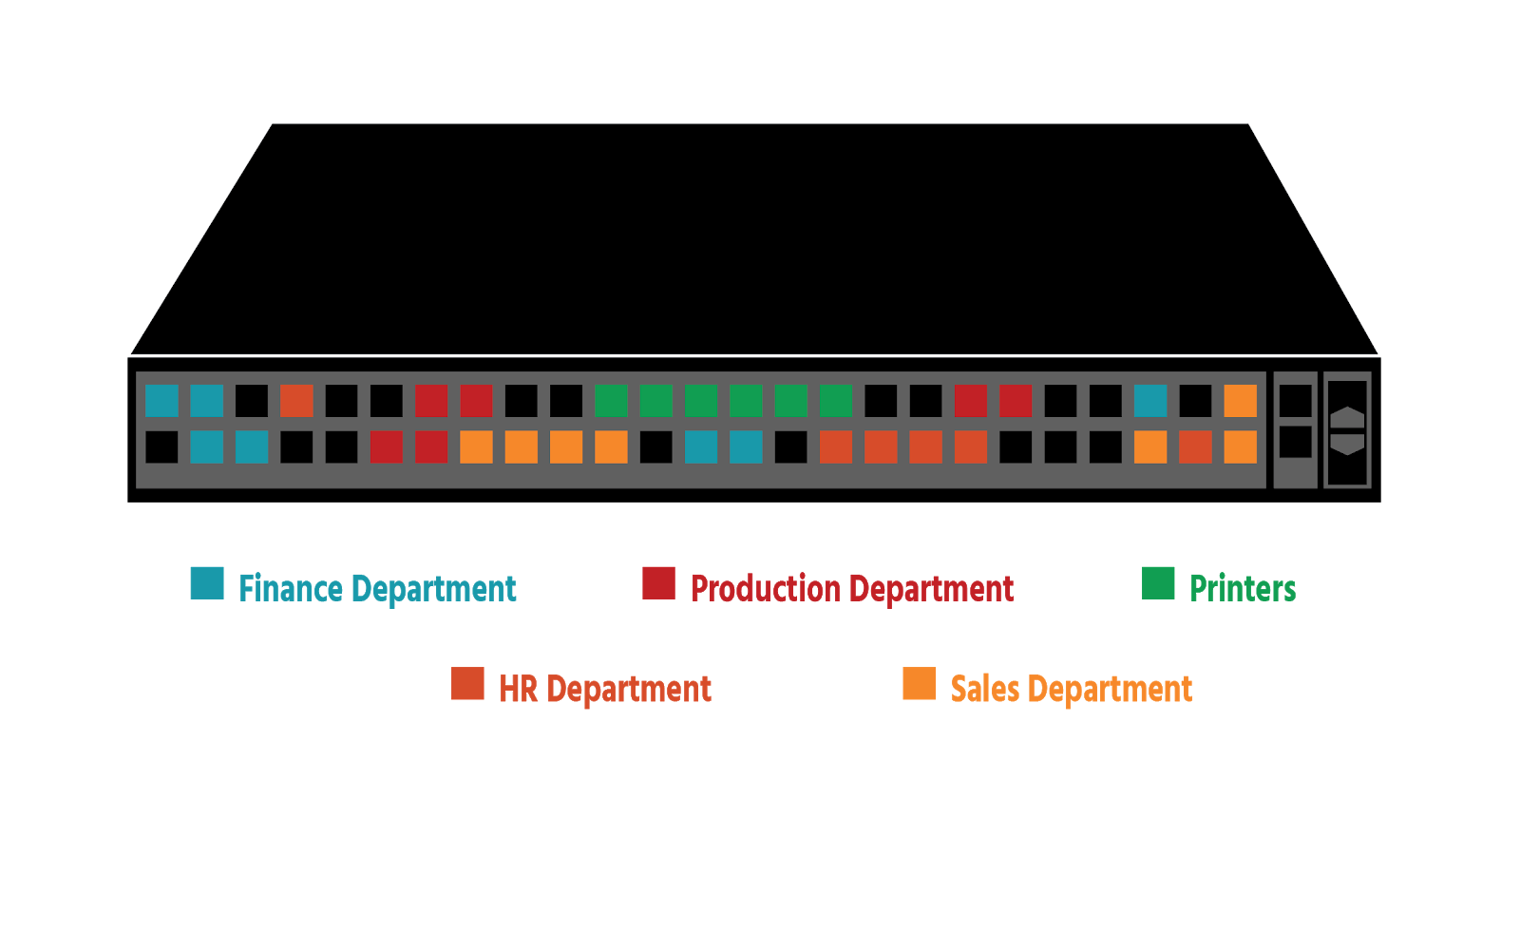

However, only a maximum of 4096 VLANS can be created on a Layer 2 (*Data Link Layer)*network. (This is a reference to the **OSI networking model**, which has 7 layers that together describe the different communication functions of a networking system.) This may seem like a lot, but imagine being a company that gave each of its customers 5 VLANS: after customer 819 you would have no more VLANS – which would mean no new customers. Security is an issue since VLANs are separated from a logical perspective but are actually running through the same connection, and a security breach on one can affect them all. And every time a VLAN is extended, a time-consuming physical configuration is needed.

With network virtualization, on the other hand, network services beyond data transfer are also available – switching, routing, firewalling, and load balancing (Layer 3 to Layer 7 functions). The network in its entirety (Finance, HR, Production, Sales, and printers) can be recreated in software in seconds, and cloned or moved if needed; or *snapshots* representing the exact state of a network at a particular point in time can be created, saved, and used to recreate the network if required. Every networking and security service is virtualized (handled in software) and attached directly to individual workloads, reducing the need for physical configuration.

What is Software-Defined Networking?

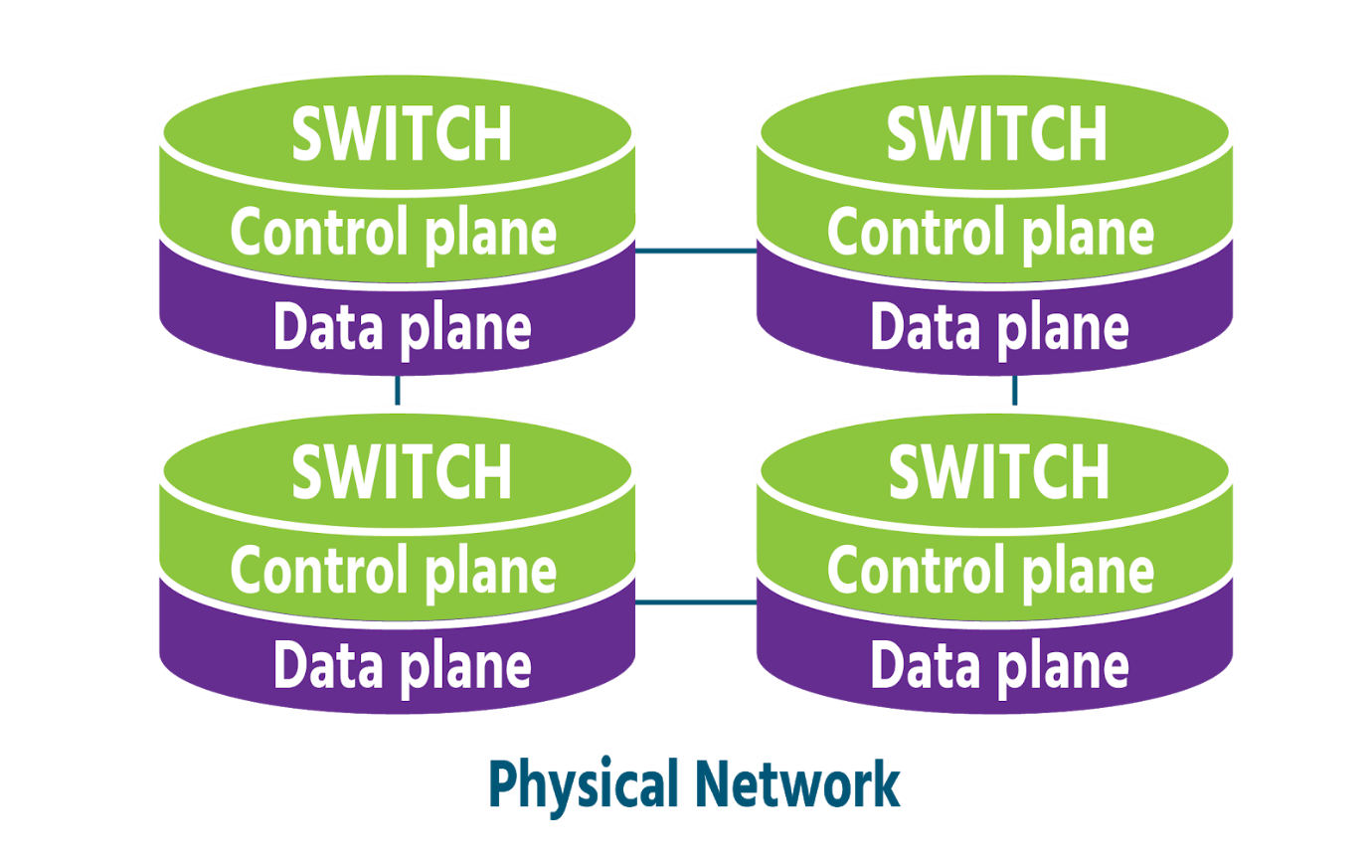

Network virtualization and *Software-Defined Networking (SDN)* stem from a common pursuit- the goal of greater network agility- and still share certain traits:

* Both use software to recreate key components of networking infrastructure
* Both separate the **control plane** (the part of the network that manages and controls it- a network's *brains*) from the **data plane** (the part where data traffic flows- a network's *muscles*) This means that with both network virtualization and SDN, network control can be programmed directly for applications and network services, without the need for manual configuration.
* Both use a **controller** that runs specialized software to centralize network management.
* Both (to varying degrees) fulfill the primary goal of increased agility by allowing administrators to quickly and precisely adjust the flow of data traffic across a network.

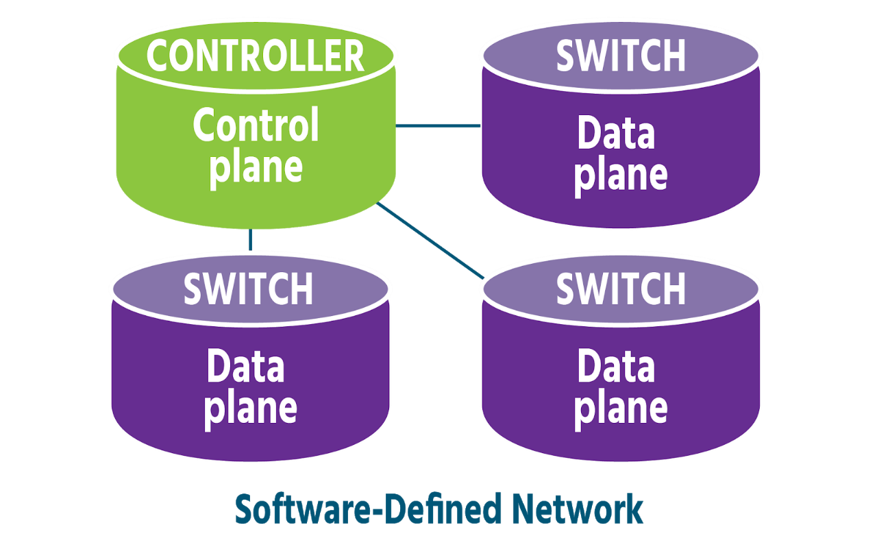

Over time, however, SDN has become more broadly-defined than network virtualization, meaning different things depending on who you speak to and how they are using SDN. The thread that links these different definitions is *SDN's use of software to control networks and their physical devices.* With SDN, software controls network switches and routers, but the network is not fully virtualized, as it is with network virtualization (components, configurations, functions, and all). Hardware often still plays a major role in an SDN network.

**Virtual Networks in Physical Networks**

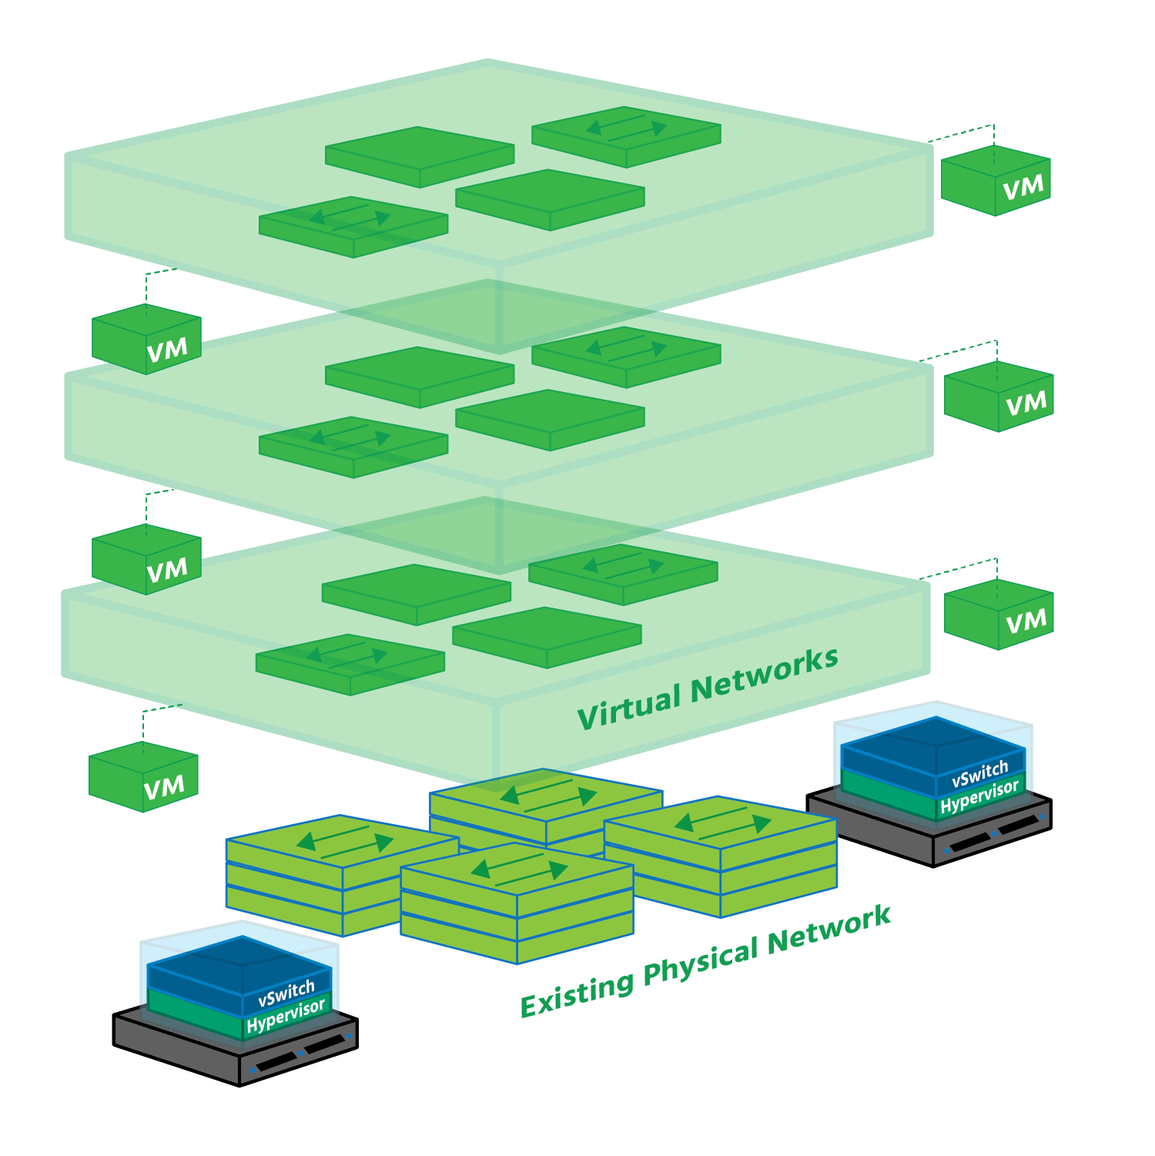

Network virtualization allows you to look at your current physical network from a fresh perspective, one in which you're no longer restricted to the capabilities of your hardware. Software vastly extends your range of possibilities, recreating your hardware as a virtualized pool that can then be used as needed, on-demand.

Imagine your physical network doubled in scope: your physical network is there doing the job it's always done, but in parallel with it you now have an identical virtual version running independently, alongside or on top of it. Once that virtual network has been created, it can be saved, closed, and restored later, possibly at another site. Or it can be deleted altogether.

Now imagine the scope of your physical network tripled, quadrupled, or more, because virtualization separates networking from the underlying hardware, you can create as many virtual networks (copies of the physical network) as you need. Each of these virtual networks runs in splendid isolation, unaffected by events in other virtual networks or in the data centre.

## Bridging Between Virtualized Networks and Traditional VLANs

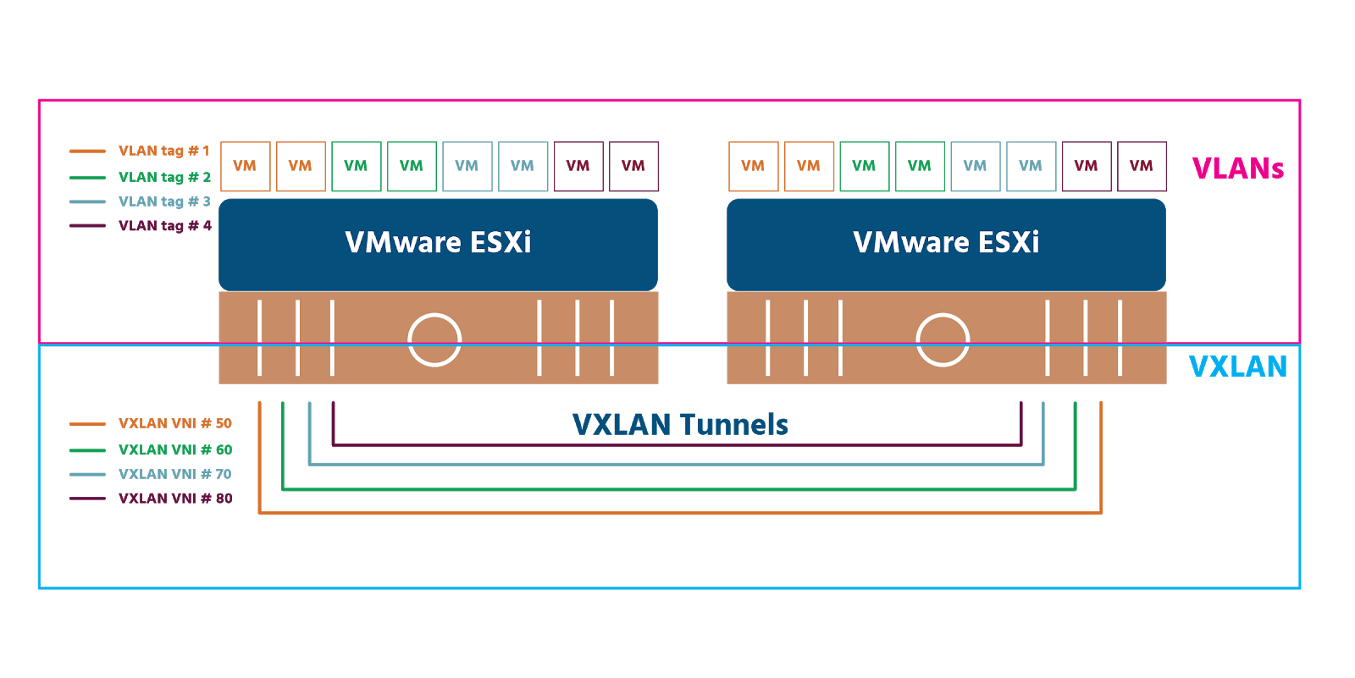

As we mentioned in section 2.1, creating a virtual network on top of a physical network is known as **overlay networking**. The underlying infrastructure becomes the underlay - also known as the physical (Layer 3) network. Several overlay methodologies exist. Two of the most widely-used are **Virtual Extensible Local Area Network** (VXLAN) and **Generic Network Virtualization Encapsulation** (GENEVE). It is important to note that VXLAN is vendor-neutral and has been recognized as RFC (Request for Comments) 7348, which is a formal document from the Internet Engineering Task Force (IETF).

VXLAN works on hardware (e.g., on routers or switches), on software (e.g., on a hypervisor) or on both (hybrid). It uses 24-bit binary identifiers (from 00000000000000000000 to 111111111111111111111111 and everything in between) meaning that a maximum 16,777,215 VXLANs are possible. Compare that to the maximum 4096 VLANs permitted by their 12-bit identifiers! A VXLAN ID is called a **VXLAN Network Identifier** (VNI). Each VNI is a separate virtual network that runs in the overlay network which are also known as **bridge domains**.

**VXLAN Tunnel Endpoints** (VTEPs) connect the physical network to the overlay network. Every VTEP has an IP address in the physical network and one or more VNIs in the overlay network. Encapsulated traffic (traffic that’s had certain information added to it at key stages of its journey - see section 4) is transferred between hosts via a stateless tunnel that is created between a source VTEP and a destination VTEP. By the time data from a host reaches a VXLAN switch, it’s in the form of frames, specifically “inner MAC frames” which include MAC (i.e., hardware) address information and data. The switches add a “VXLAN header” containing the 24-bit VNI.

The source VTEP then adds the IP address of the destination VTEP in an IP header, as well as its own IP address. It adds a **User Data Protocol** (UDP) header (UDP being the transport protocol that VXLAN uses). The MAC address of the next physical device that the frame will be delivered to on its journey is added in an Ethernet header. The physical network (the underlay) forwards the encapsulated frame on to the destination VTEP, which removes the headers in a process called **decapsulation** (mentioned again in section 4). The frame is then delivered to the destination host.

GENEVE is a relatively new entrant to the tunnel protocol field. It was jointly developed and drafted as an IETF proposal by Intel, Microsoft, Red Hat, and VMware and released in 2014. At the time this micro-course was written, GENEVE is currently going through the IETF process to become an RFC itself and so GENEVE is equally vendor-neutral. It works almost identically to VXLAN but is more flexible because it offers control plane independence between tunnel endpoints. And there’s a slight difference in terminology: GENEVE does not have VTEPs (VXLAN tunnel endpoints), just tunnel endpoints (TEPs).

It is important to note that NSX-V utilizes VXLAN overlay encapsulation, and NSX-T uses GENEVE.

# **Module 3: The Software-Defined Data Center**

## The Software-Defined Data Center (SDDC)

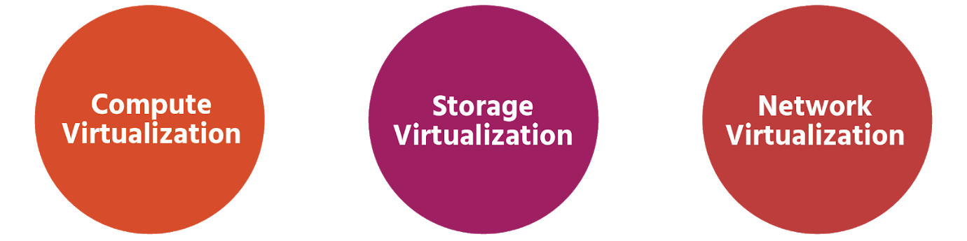

With 2.5 billion bytes of data currently being produced around the world every single day and the amount of data stored around the world doubling every two years, it's easy to see why data centres are growing in importance. It's also clear why increasing efficiency(in terms of systems and manpower) and safeguarding uptime (the number of systems that are running smoothly and available) are two of their highest priorities

Data centres have traditionally been 'hardware-centric" - focused and reliant on physical equipment. And this hardware has very often been made by vendors who charge a lot for the initial purchase(especially if the hardware has been custom-made), for maintenance and for the upgrades. This has not only been financially expensive but has also come at the cost of flexibility and agility in a rapidly-changing business landscape.

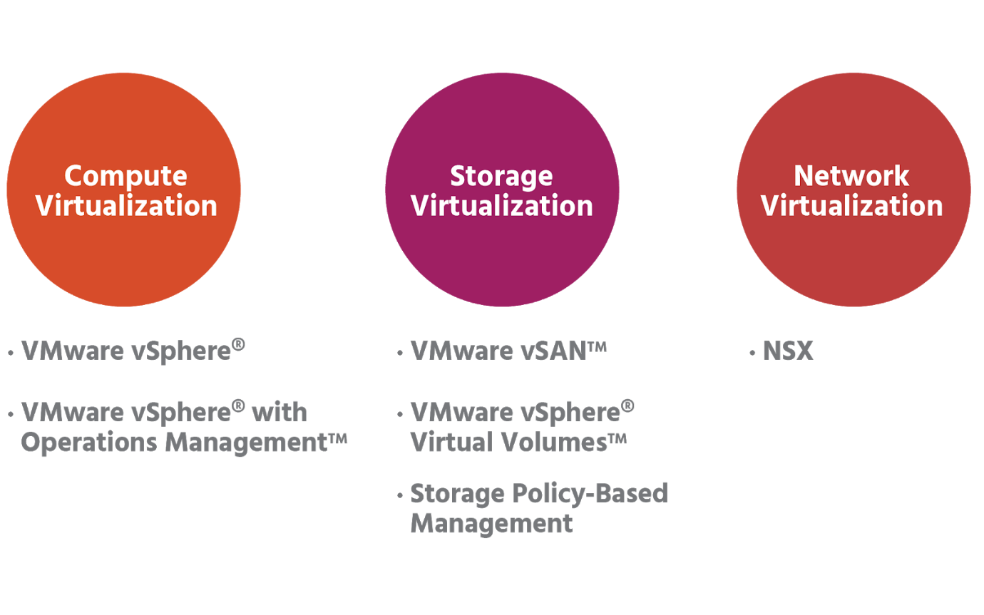

Thankfully all major services services in a data center can be virtualized. Pioneered by VMware, the **Software-Defined Data Center**(SDDC) extends virtualization beyond compute(i.e, servers) to network and storage as well. All data centre resources and services become software-defined.

Expensive vendor- specific hardware is replaced with affordable off-the-shelf industry-standard hardware. Because virtualized systems can be copied and saved, they can be easily be reproduced in the event of a system failure. And with automation, this reproduction can be almost immediate, meaning less downtime

In the software-defined data centre, the hypervisor is the controller. It pools together hardware resources which can be allocated precisely when and where they're most needed.

Management software that uses pre-defined policies vastly simplifies SDDC operations. All applications - wherever they're located - can be centrally monitored and managed. Different kinds of workloads (VMs or containers, for example) can be set up, run, and managed in different kinds of environment - physical, virtual, or cloud - using the same management software. And with automation, far fewer people are needed to do this.

## Physical Data Centres

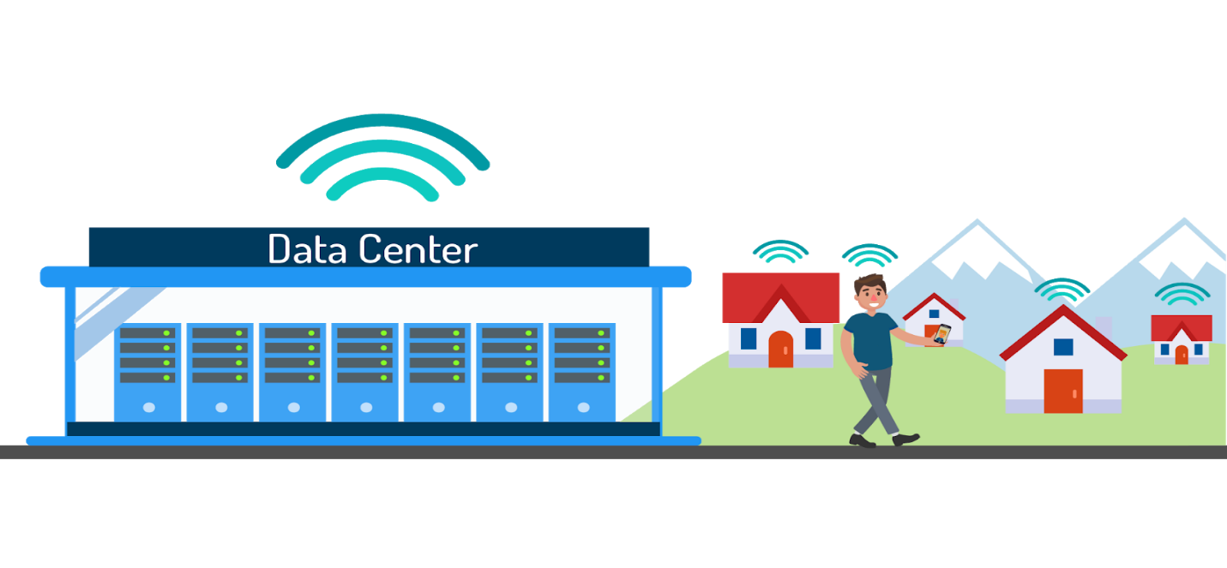

Every bit of information that you access on a device is the result of a transfer of data between where the information is processed and stored, and the device to which the data is sent. Whether you're searching for a good restaurant or the best price on a textbook, the information you find comes from a website that hosts its content in a data centre. Today, most people rely on the internet to get the majority of their information about the world around them, and most companies rely on it to reach a good proportion of their customers. This is why efficiency and agility in data centres are so vital.

Data centres are often presumed to be large warehouse-sized structures owned by a large corporation or a government, but they can also be set up on-site by small businesses and companies themselves. These data centres house computer systems, called servers, that are used to share or compute data for clients such as a smartphone user or a business website faster than a regular computer could.

Data centre infrastructure consists of three main components: compute systems (a server or host), storage devices, and networks. In a physical data centre, this will all be hardware, and massive amounts of it are needed for all the data currently in circulation. It was estimated in 2016, for example, that Google had 2.5 million servers at the time.

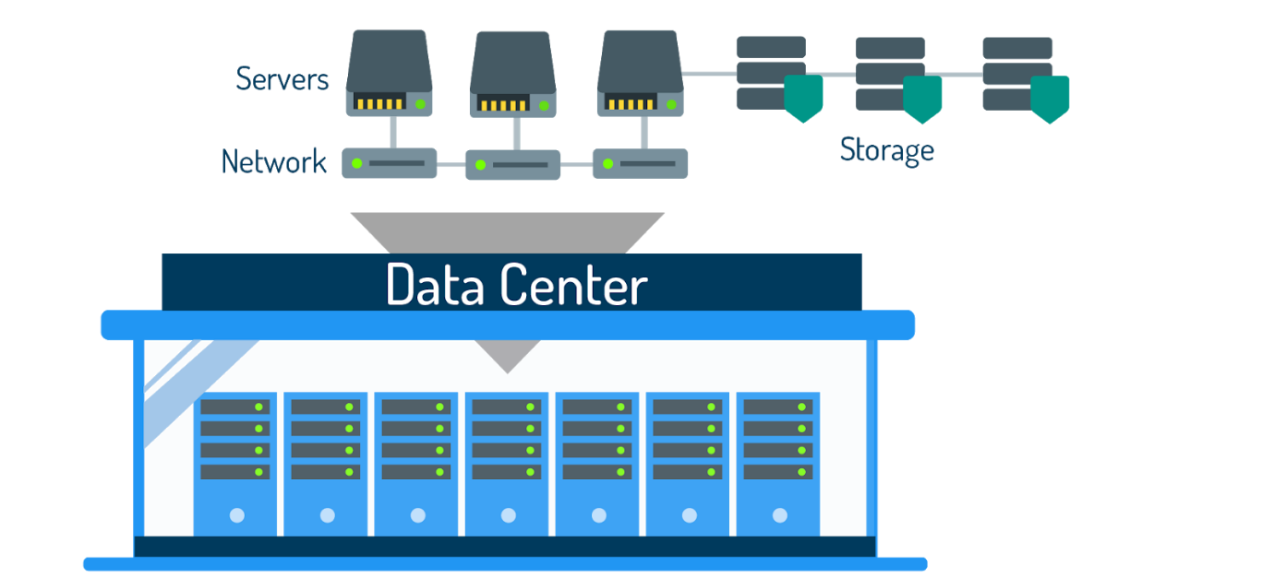

Effective management means monitoring data availability, capacity, and performance, and providing robust data security (as well as power management, effective cooling systems, and security measures).

As mentioned in the last section, physical data centers are inflexible. They’re also costly to maintain with multiple manual processes and disconnected operations. Even with compute and storage virtualization, applications are still linked to the physical network infrastructure. Without network virtualization, data center operations will remain very manual, and therefore slow and expensive.

## Virtualized Data Centers

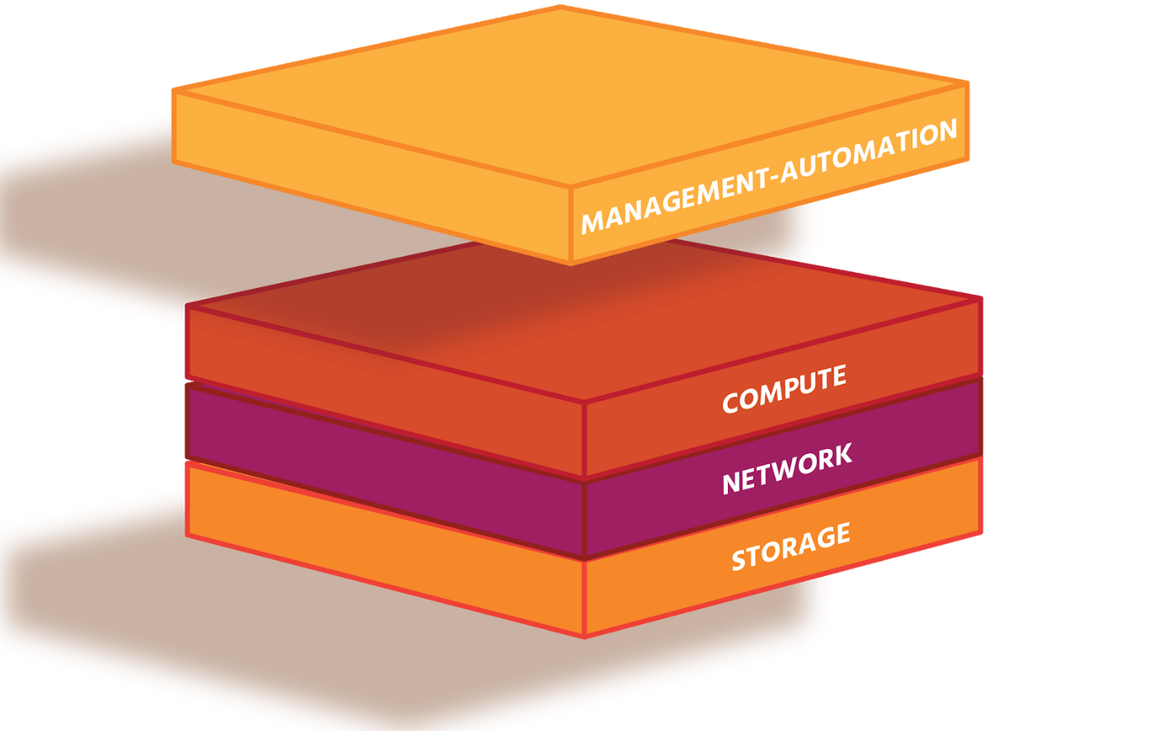

Software-defined data centers solve the problems of cost, complexity, inefficiency, and inflexibility posed by physical data centers. A fully-virtualized SDDC will encompass compute, storage, networking infrastructure and cloud management, making data center services as inexpensive and as easy to configure and manage as virtual machines. Not only does the move away from vendor-specific hardware reduce purchasing and maintenance bills, but it also removes the need for costly training on how to use this highly-specialized and often custom-made hardware.

The main benefit of virtualization in the SDDC is the ability to gather physical resources such as CPU, memory, storage, and network I/O (data transfer from one device into another) into logical (i.e., non-physical) pools, which can then be allocated to individual VMs or containers (workloads).

The use of management and automation software means that these virtualized resources can be quickly provided when needed and adjusted as needs change. The use of policies (pre-defined rules) means that this can be done with consistency and precision. Automation has the further benefit of releasing highly-skilled staff from repetitive tasks into more productive, value-adding activities.

Information can be collected from the data centre environment (using, for example, VMware’s vRealize Operations Manager, which provides automated operations management for physical, virtual, and cloud infrastructures) and used to plan future capacity more accurately.

Network virtualization separates switches, routers, and network services from the underlying physical network. The network virtualization platform of VMware is NSX. It bridges the gap between physical networks and applications, reduces hardware complexity and costs, improves application availability (uptime) and speeds up system recovery.

VMware’s SDDC Approach

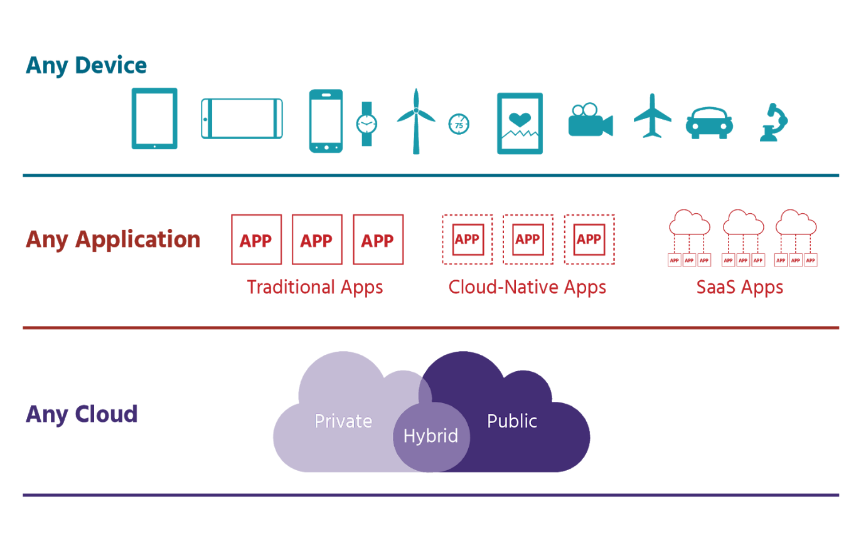

Software powers the growth and development of networks and data center infrastructure. VMware is the creator of software-defined agility, with instant provisioning from the data center to devices. Its technologies provide advanced security that is built into (or *native to*) applications, devices, and infrastructure, and seamlessly unify private and public clouds. Using the SDDC approach, organizations can meet their business demands efficiently and flexibly, while making long-term cost savings. VMware’s vSphere for server virtualization, vSAN for storage virtualization, and NSX for network virtualization are just some of the products that help their more than half-a-million customers achieve these benefits. (We’ll look at the *NSX Data Centre* in detail in section 5).

More and more organizations are choosing to mix and match their clouds to maximize the effectiveness of their spending and resourcing. Blending on-premises private clouds with public clouds is the most common mix, and the term used to describe this ‘best of both worlds’ approach is *hybrid clouds*. A hybrid cloud strategy is integral to VMware’s vision to help their customers use any cloud to deliver any application to any device. In addition, as the majority of businesses have yet to fully-virtualize their compute, storage, and network infrastructures, VMware technologies can be brought together in natively-integrated software sets (SDDC in-a-box). Sets (or *stacks* as they’re known) such as *VMware Cloud FoundationTM*, in turn, make deploying hybrid clouds much simpler. *Cloud FoundationTM* and *Cross-CloudTM* services (together known as *VMware’s Cross-Cloud Architecture*) support VMware’s hybrid cloud strategy.

VMware has partnered with *Amazon Web Services* (AWS) to offer *VMware Cloud on AWS* (SDDC as a Service), in which a single set of software tools can be used to manage both on-premises private clouds and public clouds. This approach combines both VMware’s and AWS’s extensive compute, storage, networking, and security capabilities in one flexible and easy-to-use service.

In a nutshell, here is why VMware thinks its SDDC offers what no-one else can:

* SDDC technology means more of an organization’s infrastructure can be used more of the time, in turn making their staff more productive, and greatly reducing spending on physical equipment (known as *capital expenditure* or CapEx) and on operating costs (OpEx).
* SDDC enables the deployment of applications in minutes or even seconds with policy-driven provisioning that matches resources to continually-changing workloads and business demands.
* SDDC makes possible the right availability, security, and compliance for every application.
* SDDC supports private, public, and hybrid clouds. In each case, the infrastructure is fully abstracted from applications so they can run on multiple sets of hardware, hypervisors, and clouds.

The result of a fully-virtualized SDDC is unprecedented IT agility and efficiency, with the flexibility to support today’s and tomorrow’s hardware and applications.

Data Centre Building Blocks

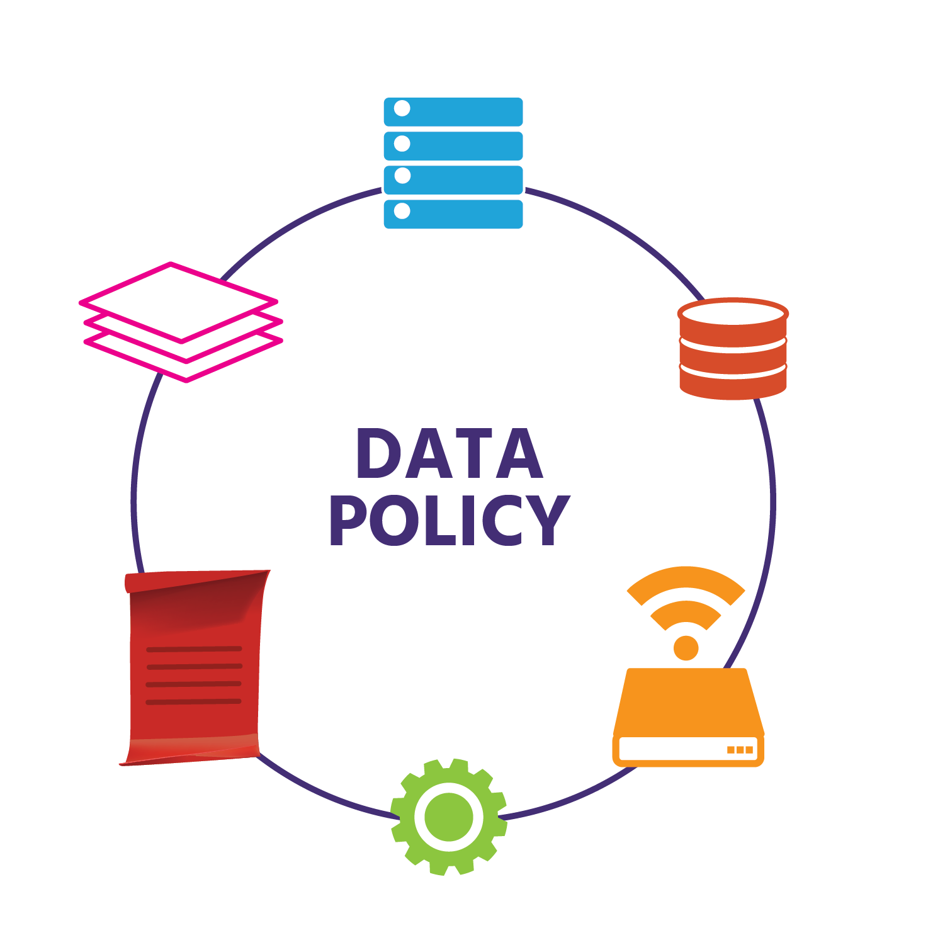

With all the components, no two data centres will be the same. However, some of the key components that an enterprise (i.e., large-scale) data centre will include are applications, servers, storage, networking infrastructure, management, and automation

As the role of virtualization in data centres increases, these key building blocks may look different. Currently, we’d expect a *fully-virtualized* data centre to:

* be software-defined: automated and managed by a single set of policy-based software tools that allow you to centrally monitor and administer all applications across different environments (physical, virtual, and cloud) and infrastructure types
* have built-in security
* be very easy to adjust in size – either *scaling out/in* by adding/removing devices, or by *scaling up/down* by adding/removing resources such as CPUs or storage to a single device
* support the latest developments in application technology, such as containers and apps specifically designed for the cloud
* support *infrastructure*as a code - i.e., support the writing of code that takes care of configuration and automates provisioning.

These building blocks will change as the SDDC grows and develops. Since the emergence of virtualization in the 1960s, with the likes of the Burroughs Corporation’s B5000 computer and IBM mainframe computers, it has changed the world. Servers have probably gone through the most innovation, with the tangible benefits including reduced physical complexity, increased operational efficiency, and simplified repurposing (i.e., virtualizing) of underlying physical resources. Today the vast majority of servers are virtualized and, in terms of networking, there are now more virtual ports being used globally than physical ones.

With an already-large range of products in data centre management and automation (*vSphere*, *vRealize*, and *NSX*, to name just three), VMware continues to innovate for its current and future customers.

# **Module 4: Network Virtualization Service**

# **Module 5: The NSX Data Centre**

# **Module 6: Where To Go From Here?**